**System overview**

“ZAGS” system is designed to register and manage applicant’s requests for various types of services.

The following roles are available in the system: “User”, “Administrator”, “System administrator”.

**General information**

Upper color indicator is switched to green, when a user proceeds registration steps. For example, a user being on step 1, clicks step 2, as a result indicators of steps 1 and 2 turn green, while further steps are displayed in grey color.

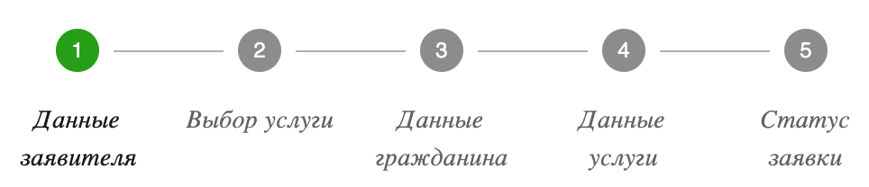

**1. “USER” ROLE**

**1.1 “Login as user”**

1. When a user clicks “Login as user” button, service registration page is displayed. Hint is displayed at the top of application form. The hint text is “You are logged in as a user”.
2. A user shall proceed 5 registration steps:

- Administrator data  
 - Select service   
 - Citizen data  
 - Service data  
 - Application status

A user shall fulfill the form displayed on step “Applicant data”. The following fields are available:

|  |  |  |  |  |
| --- | --- | --- | --- | --- |
| **№** | **Field name** | **Format** | **Required** | **Constraint** |
| 1 | Surname | Number/Text | no | Max 100 characters, including special characters, the Latin alphabet, digits. |
| 2 | Name | Number/Text | no | Max 100 characters, including the Latin alphabet, digits. |
| 3 | Middle name | Text | no | Max 100 characters, data as in passport only in the Latin alphabet, no special characters. |
| 4 | Residence address | Text | no | Max 50 characters, only letters and special characters. |
| 5 | Phone | Number | no | Max 11 characters; must include country code and operator code, the Latin alphabet and numbers are acceptable. |
| 6 | Passport number | Text/Number | yes | Max 8 characters; only numbers (0-8) and Russian letters are acceptable. If no data is entered, the field is highlighted in red. |

1. “Next” button displayed in bottom left corner shall be clicked to proceed to the following step of the registration.
2. “Close” button shall be clicked to return to home page.
3. When “Next” button is clicked, a user proceeds to the following step “Select service”.
4. The following services (clickable buttons) are available to user:

- Registration of marriage;

- Registration of birth;

- Registration of death;

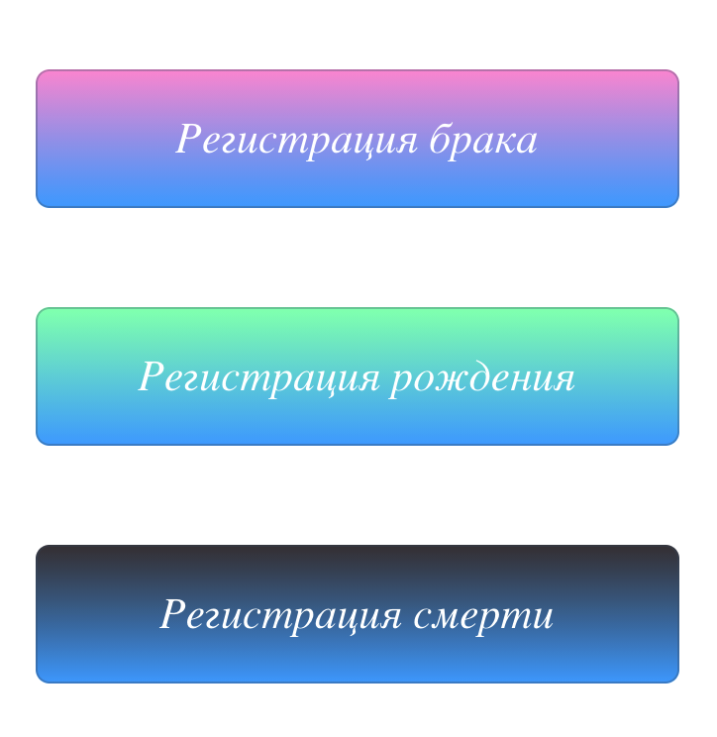

In order to choose a service, a user shall press the button corresponding to the type of service.

**1.2 “Registration of marriage” service**

After clicking “Registration of marriage” button, a user shall complete a form. The following fields are available in the form: “Surname”, “Name”, “Middle name”, “Resinedce address”, “Passport number”, “Sex”. Fulfilling requirements (step 3):

|  |  |  |  |  |
| --- | --- | --- | --- | --- |
| **№** | **Field name** | **Format** | **Required** | **Constraint** |
| 1 | Surname | Number/Text | yes | Max 100 characters, including special characters, the Latin alphabet, digits. |
| 2 | Name | Number/Text | yes | Max 100 characters, including the Latin alphabet, digits. |
| 3 | Middle name | Text | yes | Max 100 characters, data as in passport only in the Latin alphabet, no special characters. |
| 4 | Residence address | Text | no | Max 50 characters, only letters and special characters. |
| 5 | Date of birth | Datepicker | yes | Hint DD.MM.YYYY is displayed in the field. After entering a date, the hint is replaced by date; for example, DD 31 if user entered 31. When date is selected in datepicker, all hint text is replaced by selected date, i.e. if user selected 31.12.2020, hint text DD.MM.YYYY is replaced by 31.01.2021 |
| 6 | Passport number | Text/Number | yes | Max 8 characters; only numbers (0-8) and Russian letters are acceptable. |
| 7 | Sex | Drop-down list | yes | Values: “Male” and “Female” |

1. All fields in the form are required to complete. If no data is entered, the field is highlighted in red.
2. When all required fields are filled in, a user clicks “Next” button (it is not clickable, if all fields are not completed) and proceeds to next registration step “Service data”.
3. It is required to press “Back” button to return to home page.
4. A user shall complete the form displayed on step “Applicant data”. The following fields are available: “Registration date”, “Husband’s surname”, “Husband’s name”, “Wife’s middle name”, “Husband’s date of birth”, “Wife’s passport number”. Fulfilling requirements (step 4):

|  |  |  |  |  |
| --- | --- | --- | --- | --- |
| **№** | **Field name** | **Format** | **Required** | **Constraint** |
| 1 | Registration date | Datepicker | yes | Max 7 characters, digits. |
| 2 | Husband’s surname | Number/Text | yes | Max 50 characters, including the Latin alphabet, digits. |
| 3 | Husband’s name | Text | yes | Max 20 characters. |
| 4 | Wife’s middle name | Text | yes | Max 20 characters, letters and special characters only. |
| 5 | Husband’s date of birth | Datepicker | yes | Max 7 characters, digits. |
| 6 | Wife’s passport number | Text/Number | yes | Max 8 characters; only numbers (0-8) and Russian letters are acceptable |

1. After completing the form (all fields are required), a user clicks “Finish” button in the bottom left corner of the page.
2. By default, an application receives “Under consideration” status after being registered.
3. When “Finish” button is clicked, a user proceeds to “Application status” step. The following text is displayed on the page: “Thank you for your application!”, application date (format: DD MM YYYY, HH:ММ:SS), Application status: under consideration”.
4. “Refresh” button is available to user to refresh information. When this button is clicked, application status is refreshed.
5. User shall click “Apply” button in order to register new application. After clicking this button, a user proceeds to the first application step.

**1.3. “Registration of birth” service**

After clicking “Registration of birth” button, a user proceeds to “Citizen data” service form which a user shall complete.The form contains the following fields: “Surname”, “Name”, “Middle name”, “Resinedce address”, “Passport number”, “Sex”. Fulfilling requirements (step 3):

|  |  |  |  |  |
| --- | --- | --- | --- | --- |
| **№** | **Field name** | **Format** | **Required** | **Constraint** |
| 1 | Surname | Number/Text | yes | Max 100 characters, including special characters, the Latin alphabet, digits. |
| 2 | Name | Number/Text | yes | Max 100 characters, including the Latin alphabet, digits. |
| 3 | Middle name | Text | yes | Max 100 characters, data as in passport in the Latin alphabet only, no special characters. |
| 4 | Residence address | Text | yes | Max 30 characters, letters and special characters only. |
| 5 | Date of birth | Number | yes | - |
| 6 | Passport number | Text/Number | yes | Max 8 characters; only numbers (0-8) and Russian letters are acceptable |
| 7 | Sex | Drop-down list | yes | Values: “Male” and “Female” |

1. All fields in the form are required to complete. If no data is entered, the field is highlighted in red.
2. When all fields are filled in, a user clicks “Next” button (it is not clickable, if all fields are not completed) and proceeds to next registration step “Service data”.
3. A user shall complete the form displayed on step “Service data”. The following fields are available in the form: “Birth place”, “Mother”, “Farther”, “Grandmother”, “Grandfather”. Fulfilling requirements (step 4):

|  |  |  |  |  |
| --- | --- | --- | --- | --- |
| **№** | **Field name** | **Format** | **Required** | **Constraint** |
| 1 | Birth place | Number/Text | yes | Max 50 characters, including the Latin alphabet, digits. |
| 2 | Mother | Number/Text | yes | Max 20 characters. |
| 3 | Father | Text | yes | Max 20 characters, letters and special characters only. |
| 4 | Grandmother | Text | yes | Max 20 characters. |
| 5 | Grandfather | Text | yes | Max 20 characters. |

1. After filling out the form (all fields are required), a user clicks “Finish” button in the bottom left corner of the page.
2. By default, an application receives “Under consideration” status after being registered.
3. When “Finish” button is clicked, a user proceeds to “Application status” step. The following text is displayed on the page: “Thank you for your application!”, application date (format: DD MM YYYY, HH:ММ:SS), Application status: under consideration”.
4. “Refresh” button is available to user to refresh information. When this button is clicked, application status is refreshed.
5. User shall click “Apply” button in order to register new application. After clicking this button, a user proceeds to the first application step.

**1.4 “Registration of death” service**

After clicking “Registration of death” button, a user proceeds to “Citizen data” service form which a user shall complete.The form contains the following fields: “Surname”, “Name”, “Middle name”, “Resinedce address”, “Date of birth”, “Passport number”, “Sex”. Fulfilling requirements (step 3):

|  |  |  |  |  |
| --- | --- | --- | --- | --- |
| **№** | **Field name** | **Format** | **Required** | **Note** |
| 1 | Surname | Number/Text | yes | Max 150 characters, including special characters, the Latin alphabet, digits. |
| 2 | Name | Number/Text | yes | Max 100 characters, including the Latin alphabet, digits. |
| 3 | Middle name | Text | yes | Max 200 characters, data as in passport in the Latin alphabet only, no special characters. |
| 4 | Residence address | Text | yes | Max 30 characters, letters and special characters only. |
| 5 | Date of birth | Datepicker | yes |  |
| 6 | Passport number | Text/Number | yes | Max 8 characters; only numbers (0-8) and Russian letters are acceptable**.** |
| 7 | Sex | Drop-down list | yes | Values: “Male” and “Female” |

1. All fields in the form are required to complete. If no data is entered, the field is highlighted in red.
2. When all fields are filled in, a user clicks “Next” button (it is not clickable, if all fields are not completed) and proceeds to next registration step “Service data”.
3. A user shall fulfill the form displayed on step “Service data”. The following fields are available in the form: “Date of death”, “Place of death”. Fulfilling requirements (step 4):

|  |  |  |  |  |
| --- | --- | --- | --- | --- |
| **№** | **Field name** | **Format** | **Required** | **Note** |
| 1 | Date of death | Number | yes | datepicker. |
| 2 | Place of death | Number/Text | yes | Max 50 characters, letters and special characters only. |

1. After filling out the form (all fields are required), a user clicks “Finish” button in the bottom left corner of the page.
2. By default, an application receives “Under consideration” status after being registered.
3. When “Finish” button is clicked, a user proceeds to “Application status” step. The following text is displayed on the page: “Thank you for your application!”, application date (format: DD MM YYYY, HH:ММ:SS), Application status: under consideration”.
4. “Refresh” button is available to user to refresh information. When this button is clicked, application status is refreshed.
5. User shall click “Apply” button in order to register new application. After clicking this button, a user proceeds to the first application step.

**2. “ADMINISTRATOR” ROLE**

1. When a user clicks “Login as administrator” button, a user proceeds to “Registration data” page. Hint is displayed at the top of the form. The hint text is “You are logged in as an administrator”.
2. A user shall complete a form on this step. The form contains following fields: “Surname”, “Name”, “Middle name”, “Phone”, “Passport number”, “Date of birth”. Fulfilling requirements:

|  |  |  |  |  |
| --- | --- | --- | --- | --- |
| **№** | **Field name** | **Format** | **Required** | **Constraint** |
| 1 | Surname | Number/Text | yes | Max 100 characters, including special characters, the Latin alphabet, digits. |
| 2 | Name | Number/Text | yes | Max 100 characters, including the Latin alphabet, digits. |
| 3 | Middle name | Text | yes | Max 100 characters, data as in passport in the Latin alphabet only, no special characters. |
| 4 | Phone | Number | yes | Max 11 characters; must include country code and operator code, the Latin alphabet and numbers are acceptable. |
| 5 | Passport number | Text/Number | yes | Max 8 characters; only numbers (0-8) and Russian letters are acceptable**.** |
| 6 | Date of birth | Datepicker | no |  |

1. All fields in the form are required to complete. If no data is entered, the field is highlighted in red.
2. When all fields are filled in, a user clicks “Next” button (it is not clickable, if all fields are not completed) and proceeds to next registration step “Manage Application”.
3. User shall press “Back” button to return to the menu with role selection.
4. Table with following data is displayed in “Manage Application” section: “№ application”, “Applicant”, “Service type”, “Time”, “Status” and “Action”.
5. Description of table columns:

|  |  |  |
| --- | --- | --- |
| **Column name** | **Display format** | **Note** |
| Application№ | Number | Application number |
| Applicant | Number | Applicant number in the system |
| Service type | Service type name | “Receiving the birth certificate”, “Receiving the death certificate”, “Receiving the marriage/divorce certificate” |
| Time | DD.MM.YYYY HH:MM:SS | Application time. For example: 11.12.2021 17:53:32. LMB click on column name shall sort table values according to selected sort order. By default, all values are sorted from current date till earliest date. Active sort mode is displayed by indicator “Arrow up/down” |
| Status | Text | Rejected (red color, НЕХ value: **#c33117f2**) /  Approved (green color, НЕХ value: **#088e08**) /  Under consideration (blue color, НЕХ value: **#1b7eaf**) |
| Action | “Thumb up”, “Thumb down” buttons | When “thumb up” buttom is clicked  , application status is changed to “Approved”.  When “thumb down” buttom is clicked ,  application status is changed to “Rejected” |

In case there are no applications, the text “Currently, there are no applications” shall be displayed instead of table.

In case there are a lot of applications in the table, scroll bar shall be displayed.

To refresh data in the table, “Refresh” button is available.

To close the form, “Close” button is used.